The Rise of the Anti-Fascist Movement in a Trump America

The Rise of the Anti-Fascist Movement in a Trump America

### Matthew Knouff

MK Design Publishing

2017

Copyright © 2017 by Matthew Knouff

All rights reserved. This book or any portion thereof may not be reproduced or used in any manner whatsoever without the express written permission of the publisher except for the use of brief quotations in a book review or scholarly journal.

First Printing: 2017

ISBN 978-1-365-98878-3

MK Design  
Lafayette, IN

Dedication

*In memory of my father, Thomas Knouff, who taught me from a young age the importance of hard work and the virtue of tolerance.*

Contents

Acknowledgements aix

Foreword xi

Preface xiii

Introduction 1

I: Historical & Political Theory 3

II: Fascism in History..............................?

III: Anti-Fascism in History.......................?

IV: Philosophy of Antifa..........................?

Appendix 1 5

Notes 7

References 9

Glossary 11

**Delete this instructional text when formatting your book.**

**[Style = Indent Normal]**

The Contents page is set on the first right-hand page after the Copyright page or Dedication (if included). This page establishes the design motif for the remaining front matter (Acknowledgements, Preface, Foreword, Introduction, etc.), chapter headings, and back matter pages.

At a minimum, the Contents page should list all of the front matter pages that follow the contents page and the part, section, and chapter headings in the book. The Contents pages may also include all or some of the book’s subheadings, but does not include the Dedication or the Contents page itself.

A simple contents page might have the word “Contents” set in 18 or 20-point type in the same font as the other front matter headings, centered, about 2 inches from the top of the page. It is customary to leave about an inch or so space between the contents title and the text that comes below. The front matter and chapter heading text on your Contents page should be left aligned on the page, while the page numbers are right aligned.

Once you have edited all the sections of your book and added your book’s text, right click on the table of contents and choose **Update Field > Update Entire Table**.

For additional information about using Microsoft Word’s table of contents creation tool, see: [Create or Edit a Table of Contents](http://office.microsoft.com/en-us/word-help/create-a-table-of-contents-or-update-a-table-of-contents-HP010368778.aspx?CTT=1)

**Note**: Many works of fiction do not list chapters on a Contents page unless the chapters are individually named. In a print book, there is no need to include a Table of Contents that simply lists Chapter 1, Chapter 2, Chapter 3, etc.

If your table of contents requires multiple pages, the final contents page should appear on an even numbered page (left side of an open book). A section break is included below to automatically insert the required blank page if required.

# Acknowledgements

I would like to thank my teachers, my editor, my creative writing course classmates, and my family without whose help this book would never have been completed.

Thank you for your patience and guidance, your use of the editor’s red pen…

**Delete this instructional text when formatting your book.**

**[Style = Indent Normal]**

The Acknowledgments page is usually the first of the front matter pages following the Contents pages. While the Dedication is usually only a few words or lines of text, the Acknowledgments page provides authors a chance to acknowledge or thank anyone they wish, especially people who were involved in the writing or production process.

If your Acknowledgement text requires multiple pages, the final page should be on an even numbered page (left side of an open book). A section break is included below to automatically insert the required blank page if required.

**If you are not including Acknowledgements, delete this page from the template.**

# Preface

<Insert Preface text here. >

**Delete this instructional text when formatting your book.**

**[Style = Indent Normal]**

When there is a Preface, it is almost always written by the author.

Unlike the Introduction, which contains information essential to understanding the book, the Preface is a chance for the author to speak directly to the reader. The Preface often explains the author’s thoughts concerning the book’s inspiration; however, there are no limits on what the author can write.

If your Preface includes multiple pages, the final page should be on an even numbered page (left side of an open book). A section break is included below to automatically insert the required blank page if required.

**If you are not including a Preface, delete this page from the template.**

# Introduction

Anti-fascist movements have existed in society for centuries, in many different forms, but usually remain rather underground until a single or set of societal issues, inspiring a resurgence in membership in the group. Liberal cities and college campuses provide access to numerous individuals who may be looking for a group to become a member or may have been taught by a person in authority, such as a college professor, that fighting against perceived injustices is a virtue.

The election of Donald Trump was one of the most unexpected political upsets ever, according to many analysts. He won through a grassroots movement, focusing on social media campaigns and inspiring people who had given up on politics to register to vote. Issues such as immigration, health care reform especially issues related to women's care, terrorism and globalism vs. nationalism created a divide between many Americans, separating some Americans into two perceived extreme groups, “the left” and the “alt-right”.

Leading up to and following the election, numerous groups protested Donald Trump. College campuses flooded with students with signs, shouting down Donald Trump and the perceived threats to society by his views and proposed policies. Others took to Facebook, Twitter and other platforms to express their disapproval, with many expressing their desires for the newly elected President to be assassinated or impeached.

Groups of individuals with bandannas and other facial coverings, wearing all black with flags emerged at many of these protests. From the Berkeley riot which stopped Milo Yiannopolis from giving his speech, to the Deploraball and Women's March in D.C., a group identified as Antifa sought to express their disapproval through any means necessary. Chants and marches in the streets were part of their tactics. However, throwing bricks, hitting people with flagpoles and other objects, pepperspray and even throwing M-80's were included in the arsenal of tactics to create civil unrest and bring attention to the perceived societal threats of a Trump presidency.

The goal of this book is to provide a comprehensive overview of the anti-fascist movement, starting with a brief history of anti-fascist and anarcho-communist movements, identification of core values and beliefs of the group and their end goals and to provide a historical and ethnographic account of Antifa and related groups in our current society.

# I – Historical & Political Theory

**Background Information**

*The Political Spectrum*

To fully understand fascism and the resulting anti-fascist movements, it's necessary to define the underlying political views. While most define the fascist politics of Benito Mussolini as being far-right and socialism and communism as being far-left, the typical left-right political spectrum fails to encapsulate the similarities in the the actions taken by both fascist and communist regimes.

The linear political spectrum which defines the far-right as fascism and the far-left as communism fails with certain political ideologies, such as **anarchism** or **anarcho-capitalism**, or even libertarianism. The left-right paradigm results in totalitarian government on both ends of the spectrum, with what is essentially **Fabian socialism** in the middle. The far-right includes **national socialism** and the far-left includes international socialism. With this spectrum, socialism is an unavoidable end result of any government.

Instead of utilizing a one-dimensional political spectrum, a two-dimensional spectrum will be utilized to provide a better movements. Economic freedom is expressed on the x-axis and personal freedom on the y-axis. This creates four quadrants:

- low personal freedom, low economic freedom: authoritarism

- high personal freedom, low economic freedom: progressivism

- low personal freedom, high economic freedom: conservativism

- high personal freedom, high economic freedom: classical liberalism, libertarianism

In this spectrum, socialism, communism and fascism all share the common political expression of low economic freedom, since the state seeks gain control over business and industry, and also low personal freedom, since the government seeks to control freedom of the press and eliminate all expressions perceived as having anti-government sentiments.

**History as a Cycle**

*Introduction*

*“Modern societies too often reject circles for straight lines between starts and finishes. Believers in linear progress, we feel the need to keep moving forward. The more we endeavor to defeat nature, the more profoundly we land at the mercy of its deeper rhythms.”[1]1*

Many historians, philosophers and other intellectuals have expressed the idea of history repeating itself, whether through clothing fads, musical taste, aesthetic preferences, common generational virtues, etc. William Strauss (1997), in *The Fourth Turning*, presents as case for a cyclical view of Anglo-Saxon history, with each **saeculum** being divided into four common, but distinctively different from each other in expression and values, generations, each reactive to the previous in predictable ways.

Strauss's theory correlates with the average life expectancy of Western persons being approximately 80 years, and each lifespan being divisible into four parts: childhood, young adult, midlife, elderhood. A generation consists of a grouping of individuals born in an approximate 20 year period. The first generation of a saeculum is a dominant generation, with a reactive, recessive generation following, which is followed by the third generation which is a dominant generation, followed by a fourth generation, which is recessive. Just as a pendulum swings back and forth, generational cohorts and their historical periods swing back and forth as well. Each generational shift is referred to as a turning.

In *The Fourth Turning*,

*New World Saeculum*

Puritan Generation

The first American colonial settlement saeculum is the New World saeculum. This saeculum emerged on the tail end of the Anglo-Spanish War, with the Armada crises. The Puritan generation, born between 1588 and 1617, was marked by the desire to colonize the New World through group cooperation and conformity.

One of the first settlements, funded by Sir Walter Raleigh, was Roanoke Island, which began in 1585, resulted in the first native born Anglo-American, Virginia Dare, and resulted in confusion when a supplies ship returned in the late summer of 1590, only to discover that houses and other constructions were disassembled, all of the residents were nowhere to be found, and the only clues left were two carvings in different trees: one reading “croatoan” and the other reading “cro”, likely a reference to a group of natives or a nearby island. Before leaving to obtain more supplies, John White instructed that a cross be carved in a nearby tree if the group was forced to leave; no such designation was found.

Despite the likely disastrous results of Roanoke settlement, further attempts at permanent colonization occurred. The recognized first permanent colony, Jamestown, occurred in 1607, and despite some setbacks, was successful. This generation ended with the House of Burgesses, the first elected legislative body created by the colonists in the New World.

Cavalier Generation

The Cavalier generation, born between 1618 and 1647, emerged as a reaction to the preceding Puritan generation, after coming of age during a time of instability of the institutions of religion and family. While the Cavalier generation in the Old World is most popularly remembered by lavish dress, and long, curly hair, the New World generation faced hardship in the struggle to establish colonies with conflicts against difficult environmental conditions, competing Native American groups and colonial-royal and intra-group difficulties.

The founding of the Chesapeake colonies and colonization of the modern-day New England region occurred during the Cavalier generation. Economic difficulties in the Old World resulted in increasing rates of parental debt, illness and early death. Youth of indebted, deceased parents were forced into indentured servitude in tobacco fields and in other areas of production in the New World. Others became fur trappers and merchants.

Rising expansion led to increased conflict, escalating to the 2nd Anglo-Powatan War and subsequent Treaty of 1646. In 1622, 347 deaths occurred during the Jamestown Massacre at the hands of the Powhatan Confederacy. Other conflicts occurred with the Pequot Indians and the Iroquois Confederacy.

Glorious Generation

Enlightenment Generation

Revolutionary Saeculum

# Ch 2 – History of Anti-Fascism

**Introduction**

**The Italian Fascist Movement**

*Benito Mussolini & the Rise of the National Fascist Movement*

*“In the Fascist conception of history, man is man only by virtue of spiritual process to which he contributes as a member of the family, them social group, the nation, and in function of history to which all nations bring their contribution.”[2]2*

The history of fascism in Italy arose from numerous factors, including a public fearing a coup d'etat similar to that of Joseph Stalin in Russia, unfavorable economic conditions following World War I and a public distrust in the government at the time, led by Prime Minister Luigi Facta. In order to fully understand fascism in Italy, it's necessary to understand the most prominent individual involved in the movement, Benito Mussolini.

Mussolini's early exposure to socialist policies influenced his later political views and actions as a leader of the facist movement. In 1902, Mussolini emigrated to Switzerland to avoid compulsary military service in Italy. During his time in Switzerland, he became exposed to the philosophy of Friedrich Nietzsche and syndicalist Georges Sorel. Sorel advocated for the use of violent force to overthrow liberal democracy and capitalism. Mussolini became actively involved in the socialist movement, working as a journalist for *L'Avvenire del Lavatore* and as a secretary for the Italian worker's union in Lausanne. Mussolini was arrested (see Appendix 1-A for booking document) for inciting political violence during a general strike in Berne, Switzerland and was subsequently deported to Italy.

After deportation to Italy, Mussolini became active in the socialist movement in Italy. Mussolini, a former leading member of the Partito Socialista Italiano (PSI, or the Italian Socialist Party), was expelled from the party for supporting Socialist International, a group which organized socialist and communist insurrections during the early 20th century. Mussolini believed the neutrality stance of the PSI was detrimental to Italy's own interests. Mussolini served in the Regio Esercito Italiano (Royal Italian Army) until 1917, when he was wounded and subsequently discharged. After serving in World War I, Mussolini shifted his focus to creating political change in Italy.

Mussolini shifted his political views away from socialism to nationalism and created the Partito Nazionale Fascista (National Fascist Party), which gained significant support from the military, business class and the right-wing. This spawned a militant group, Milizia Volontaria per la Sicurezza Nazionale, more commonly known as the **Squadristi** or “blackshirts”.

In an attempt to gain a majority following, Mussolini drafted a truce with the socialists, named the “Pacification Pact”. However, this was dissolved in November 2011. Despite difficulty creating an alliance with the Italian socialists, the National Fascist Party continued to gain support, with approximately 700,000 members in July 1922. In August 1922, an anti-fascist movement attempted a general strike. However, a failure to gain public support and support from the Italian People's Party hindered its effectiveness, and the National Fascist Movement continued to gain support and power.

In October 1922, Mussolini and the National Fascist Party devised and proceeded with a plan to siege Rome. A few days before the March on Rome, Mussolini sought approval from U.S. Ambassador Richard Washburn Child. Ambassador Child encouraged Mussolini to proceed. Led by the **Quadrumvirs**, the March on Rome proceeded. Prime Minister Luigi Facta ordered a state of siege on Rome. Mussolini and the National Fascist Party demanded the immediate resignation of Prime Minister Facta. King Victor Emannuel III refused to sign the military order and on October 29th, 1922, granted Benito Mussolini the position of Prime Minister.

*The Dictatorship of Mussolini*

*“Always an irresponsible improviser, half madman, half criminal, gifted only – but to the highest degree – in the arts of 'propoganda' and mystification”2[3]3*

After taking rule in 1922, the government of Italy had a period of chaos. As a result of believing only he could restore order to Italy, he appointed himself as Il Duce – the dictator – in 1925. During the early part of his dictatorship, the value of the **lira** began to fall because of international speculation against non-gold backed currencies. Mussolini sought to halt the drop in the currency's value by issuing a deflationary policy and placing a rate freeze on the value of the lira. This led to the cost of Italian products on the international market to rise in price. Mussolini instituted policy which caused a 20% reduction in wages to facilitate lower producer costs, with the publicly stated goal of reducing the cost of goods, but this had little effect. Other policies designed to improve economic conditions had mixed results.

During the early 1930s, Mussolini sought to transform the Italian people into a strong militant group. The Opera Nazionale Balilla included seven youth organizations designated to create a future generation of loyal Italian fascists. University students were required to join Gioventu Universitaria Fascita (GUF) as a measure to monitor intellectuals for any anti-fascist views. During this time, Mussolini created an alliance with the Catholic Church, recognizing that despite being an atheist, it would be necessary to gain support from the public.

During World War II, Mussolini created an alliance with Hitler, conquered Ethiopia, seizing Albania and helped the Nationalists win the Spanish civil war. Mussolini struggled due to lack of technological advancement and lack of strong leadership amongst his generals, and in late 1942, the Allied forces were consistently victorious against the Axis forces. Mussolini suggested to Hitler that both make peace with Stalin and ally against Allied forces. However, Hitler refused. The subsequent Sicilian invasion, the King overthrew Mussolini in 1943. Hitler installed Mussolini as a puppet dictator over northern Italy during the final two years of the war.

After the Axis forces surrendered to the Allied forces, Mussolini attempted to flee. While traveling with German convoy near the village of Dongo, communist forces led by Pier Luigi Bellini delle Stelle and Urban Lazzaro stopped the convoy. In exchange for handing over all of the Italians, the German convoy would be allowed to proceed. Mussolini was found hiding in one of the convoys, and was subsequently taken into custody. On the following day, Mussolini, his mistress and sixteen other Fascist leaders were executed per an order from the communist party leadership.

**British Union of Fascists (BUF)**

The BUF, formed by Sir Oswald Mosley in 1932, received early support from *The Daily Mail* and claimed membership of over 50,000, but never gained as much traction as other fascist groups in the World War II era in Europe.

# Ch 3 – History of Anti-Fascism

**Italian Anti-Fascist Movements**

# Ch 4 – Philosophy

***Post-modernism***

***Frankfurt school***

# Appendix 1

***Appendix 1 A***

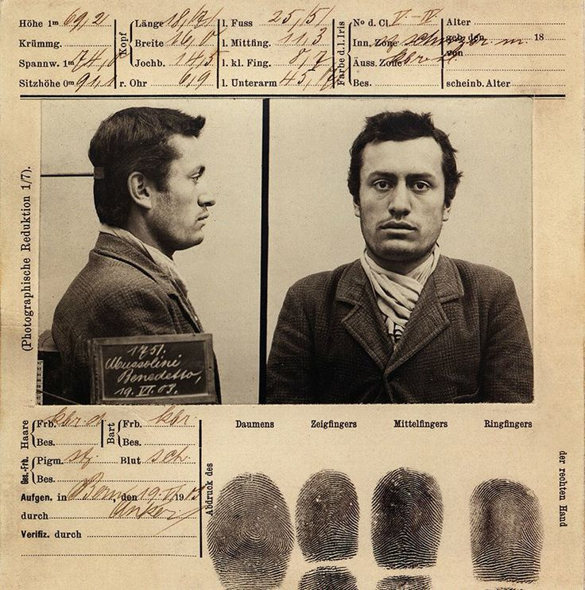

***Appendix 1B***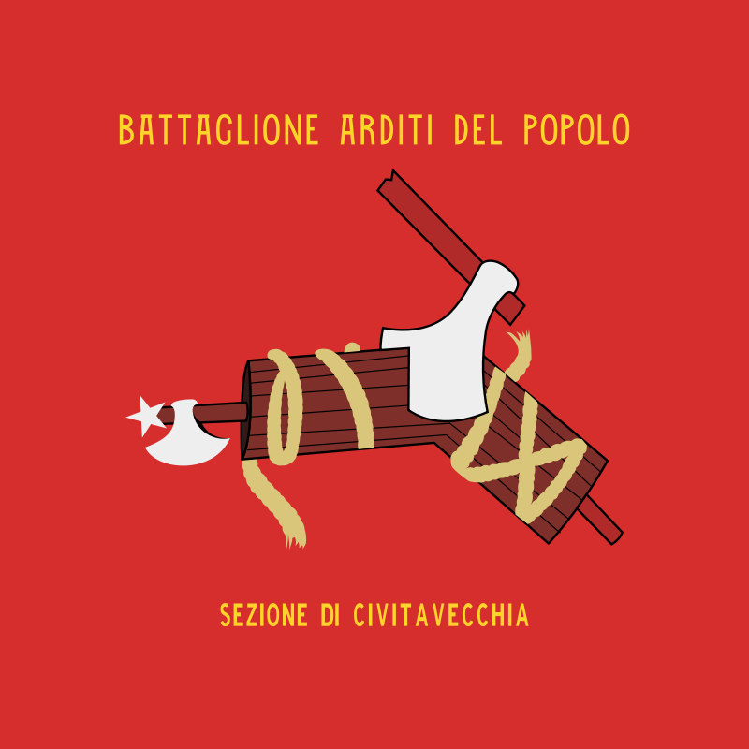

# Notes

# Bibliography

“1985-2001: A Short History of Anti-Fascist Action (AFA)”. Retrieved May 26, 2017, from https://libcom.org/history/articles/afa-anti- fascist-action.

Allen, Gary. *None Dare Call It Conspiracy.* 1972.

“Antifa Goons Panic After Masked Professor Who Bludgeoned Trump Supporter with Bike Lock is Identified & Exposed”. *The Gateway Pundit.* June 7, 2017.

“Antifa Moron Complains 'Too Many Men in Movement' and Men Should Dress Like Women.” *Libertas Daily.* March 26, 2017. http://libertasdaily.com/2017/03/26/antifa-moron-complains-many- men-movement.

Antifa Sacramento. “Points of Unity”. Accessed April 24, 2017. <http://antifasacblogs.com/points-of-unity>.

“ANTIFA Upset For Not Being Able To Punch 'Nazis' Without Consequences”. *ZeroHedge.* April 22, 2017.

Arato, Andrew & Gebhardt, Eike, Eds. *The Essential Frankfurt School Reader*. New York: Continuum, 1985.

Azzi, Stephan Corrado. “The Historiography of Fascist Foreign Policy.” *The Historical Journal,* 36(1), March 1993.

Baginski, Max. “The Pioneer of Communist Anarchism in America”*. Mother Earth,* Volume 6, March 1911.

Balhorn, Loren. *“*The Lost History of Antifa”. May 8, 2017.

Barron, Benjamin. “A Mysterious Revival of Roman Passion”. Senior Thesis, Georgetown University, .

“Berkeley Antifa Attacker Unmasked As UC Employee? CNN and

Young Turks Lookin’ So Dumb”. *Zero Hedge,* Feburary 3, 2017.

Boettke, Peter. *Calculation & Coordination: Essays on Socialism & Transitional Politcal Economy.* New York: Routledge. 2001.

Bowen, James et al. *Changing Anarchism.* Manchester, UK: Manchester University Press. 2004.

Caruso, Justin. “Berkeley Mayor Publicly Belongs to Violent Leftist Group”. *The Daily Caller*, April 24, 2017.

“The Colonial Cycle (1589-1692)”. Retrieved June 5, 2017, from http://www.timepage.org/cyc/colo.html

Coulter, Ann. *Adios America.* Washington, DC: Salem Media Group, 2015.

“Excerpts from Frame of Government of Pennsylvania, 1682”. Retrieved June 5, 2017 from http://www.constitution.org/bcp/frampenn.htm.

Flynn, John. *As We Go Marching.* New York: Doubleday & Co. 1973.

Fontenis, Georges. *Manifesto of Libertarian Communism.* 1953.

“Forming an Antifa Group.” Accessed May 26, 2017. https://itsgoingdown.org/wp- content/uploads/2017/02/howtoantifa-revised.pdf.

Graham, Robert. *Anarchism – A Documentary History of Libertarian Ideas – Volume One: From Anarchy to Anarchism (300CE to 1939).* Black Rose Media Books, 2005.

Haney, Jade. “Student Has Home Vandalized After 'Trolling' Antifa Groups”. *Campus Reform*, February 28, 2017.

Hattingh, Shawn. *The Deepening Capitalist Crisis: From Blood and Dirt to ic Much Worse.* Zabalaza Books.

Hicks, Stephen R.C. *Explaining Postmodernism: Skepticism & Socialism from Rousseau to Foucault.* Tempe, AZ: Scholargy Publishing, 2004.

Hoppe, Hans-Hermann. *A Theory of Socialism & Capitalism.* Norwell, MA: Kluwer Academic Publishers. 2010.

Kropotkin, Peter. *Anarchist Communism: Its Basis and Principles.* 1927.

Kropotkin, Peter. *Communism and Anarchy.* 1901.

Ingles, El. “The Blackhoods of Antifa.” *The Brussels Journal.* Accessed May 25, 2017. <https://www.brusselsjournal.com/node/3566>.

“The Italian Resistance”. YouTube video, 20 min. Posted March 2017.

Laila, Cristina. “Confirmed: Berkeley Mayor Jesse Arreguin Publicly Supports Violent Left-Wing ANTIFA Group”. *The Gateway Pundit****,*** April 21, 2017. http://www.thegatewaypundit.com/2017/04/berkeley.

Lennard, Natasha. “Anti-Fascists Will Fight Trump's Fascism in the Streets”. *The Nation*, January 19, 2017.

Levant, Ezra. “Berkeley vs. Milo: 'That's Not a Protest. That's a Riot”. *The Rebel,* February 3, 2017.

Life Course Associates. “Generations in History”. Retrieved June 4, 2017 from http://www.lifecourse.com/assets/files/gens_in_history(1).pdf.

McInnes, Gavin. “In Berkeley Last Saturday, We Took the Culture Back.” *The Rebel*, April 17, 2017.

McInnes, Gavin. “Fighting 'Anti-Fascist' Protesters is Fun”. *The Rebel,*

February 6, 2017.

Molyneux, Stephan. “Antifa Violence Exposed.” Filmed April 24th, 2017. FreeDomainRadio, 44 min. Posted April 2017. http://www.youtu.be/Tb54GoVR2m4.

Morse, Brandon. “Antifa Group Behind Violent Riots Discovered to Have Ties to Pedophile Group”. *The Blaze*, May 1, 2017.

Morse, Brandon. “Antifa Wants Combat Training and Firearm After Losing the 'Battle for Berkeley'. *The Rebel,* April 21, 2017.

“Mostly Forgotten History: The Maryland Wars.” Retrieved June 5, 2017 from http://m.dailykos.com/story/2014/2/16/1278088/-mostly- forgotten-history-the-maryland-wars.

Mowat, R.B. *History of European Diplomacy, 1451-1789.* 1928.

Mussolini, Benito. “The Doctrine of Fascism.” 1932. Retrieved from http://www.worldfuturefund.org/wffmaster/Reading/

Germany/mussolini.htm

Nash, Charlie. “Four Arrested at Gavin McInnes Event as Antifa Protesters Become Violent”. *Breitbart*, February 2, 2017.

Pelz, William. *A People's History of Modern Europe.* Pluto Press, 2016.

Posobiec, Jack. “Antifa: Unmasking America's Most Dangerous Domestic Terrorists”. *The Rebel,* April 20, 2017.

Raico, Ralph. *Great Wars & Great Leaders: A Libertarian Rebuttal.* Auburn, AL: Ludwig von Mises Institute. 2010.

Reich, William. *The Mass Psychology of Fascism.* New York: Farrar, Straus & Giroux, 1970.

Rose City Antifa. “Statement on Strategy and Tactics for June 4th Rally”. May 24, 2017.

Ross, Chuck. “Look Who Funds The Group Behind The Call To Arms At Milo's Berkeley Event.” *The Daily Caller.* February 3, 2017.

“Rules of Engagement”. *The Antifascist* 1 (Spring 2005).

Savage, Michael. *Abuse of Power.* New York, St. Martin's Press, 2011.

Savage, Michael. *The Enemy Within.* Nashville, TN: WND Books, 2003.

Savage, Michael. *Government Zero: No Borders, No Language, No Culture.* New York: Center Street, 2015.

Savage, Michael. *Liberalism is a Mental Disorder.*  Nashville, TN: Nelson Current, 2005.

Seldes, Georges. *Sawdust Caesar: The Untold History of Mussolini.* New York: Harper Brothers Publishers, 1935.

Senate Education Committee. *Amendment No. 1 to SB0723.* http://www.capitol.tn.gov/Bills/110/Amend/SA0333.pdf

“7 Steps That We Must Take to Defeat Antifa and Remove Violence from Political Discourse.” *Sisyphean News.* April 24, 2017. https://sisypheannews.com/2017/04/24/7-ways-to-eliminate-antifa/.

Sheffield, Matthew. “Anti-fascist Radicals: Liberals Don't Realize the Serious Danger of the Alt-Right”. *Salon.com.* March 10, 2017.

*Stop Fascism.* Chicago, IL: New America.

Strauss, William. *The Fourth Turning.* Three Rivers Press, 2009.

Strickland, Patrick. “US Anti-Fascists: We Can Make Racists Afraid

Again.” *Al Jazeera.* February 21, 2017.

Sunshine, Spencer. “The Changing Face of Anti-Fascists.” *Truthout.* January 18, 2017. <https://www.brusselsjournal.com/node/3566>.

“The Fascisti”. *Current Opinion,* October 1921, p. 430.

“Tennessee First State to Ban Domestic Terror Groups Antifa and BLM.” *Sisyphean News.* May 19, 2017. <https://sisypheannews.com/2017/05/19/tennessee-first-state-to-ban-> domestic-terror-groups-antifa-and-blm,

Trotsky, Leon. *Fascism: What It Is And How To Fight It.* 1930-1932. Retrieved from http://history.eserver.org/fighting-fascism

“The Troubling Implications of the Conflict in Berkley Today.” Accessed April 17, 2017. https://www.reddit.com/r/Anarchism/comments/65m67l.

Viehmann, Klaus. “Three Into One: The Triple Oppression of Racism, Sexism and Class.” *Quaderni di Controinformazione,* 21/22, February 1995.

# Glossary

**[Style = Glossary]**

**Lira –** the former currency of Italy, between 1861 to 2002, with the symbol ₤ used for the currency.

**Quadrumvirs** – a group of 4 leaders leading the March on Rome, including Michele Bianchi, a revolutionary syndicalist leader, Emilio de Bono, an Italian General and veteran of World War I, Cesare Maria de Vecchi, a colonial administrator and member of the Italian Chamber of Deputies, and Italo Balbo, the designated heir to Mussolini, a leader of the Squadristi (Blackshirts) and leader of the Ferrara Fascist organization

**Squadristi –** a militant group created by the Partito Nazionale Fascista (National Fascist Party), also known as the “blackshirts”, which held an important role in the Marcia su Roma (March on Rome) on October 1922.

If the book has a glossary, it usually comes after the Notes and Refeences sections if included. The Glossary text is usually set in the book’s main body font and size, but it can be set smaller if page count is an issue.

The glossary terms are often set off in some way, using a bold or italic font. It is also common to set off the entries with a hanging indent and/or extra space between the terms.

If your Glossary requires multiple pages, the final page should be on an even numbered page (left side of an open book). A section break is included below to automatically insert the required blank page if required.

**If you are not including a Glossary, delete this page from the template.**

**[Style = Normal Block]**

**IMPORTANT NOTE**

The total number of pages (front matter, body, and back matter) in your book must be divisible by 4. If not, the printer will insert additional pages.

The final page (front and back) of your book must be left blank. If there is any print on the final page, it will be rejected for distribution.

**THEREFORE, DELETE THE TEXT FROM THIS PAGE BEFORE UPLOADING YOUR MANUSCRIPT!**

1. Strauss, William. *The Fourth Turning.* Three Rivers Press, 2009. pg 326
2. Quote by Benito Mussolini, from *The Doctrine of Fascism*, 1932
3. Quote by Gaectano Salvemini, from Stephan Corrado Azzi. “The Historiography of Fascist Foreign Policy.” *The Historical Journal,* 36(1), March 1993.